What to expect the day of testing?

Make sure to arrive early. I was at the testing center 45 minutes early just to be safe. It was enough time to get settled in and to study my flash cards for a few minutes. Yes, I created pharmacy law flash cards. The building is a large office building with the testing center located in suite 1000. If you are testing at the Carrollton location, enter through the door on the left when looking at the building from the parking lot. You’ll see a small Pearson Vue sign in the grass. That door is the exact entrance into the testing center.

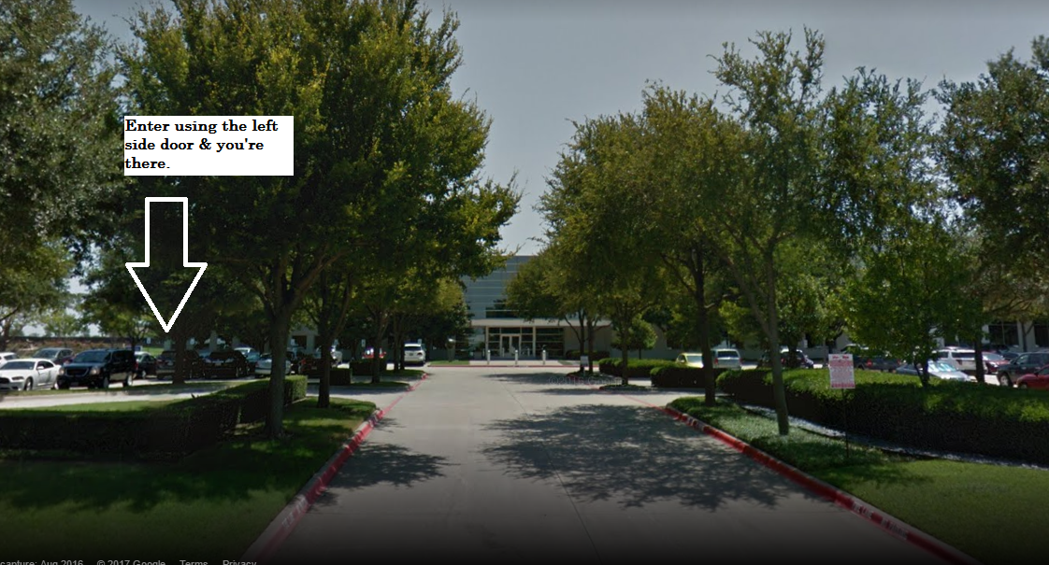

Make sure you have two forms of identification: (1) Government ID: Driver’s License or Passport (1) Picture ID: School ID, etc. You can find the proper identification information on the PTCB.org website. If you do not have this, they will not allow you to take the test! Once you walk in they will take your ID and check you in. They will scan the palm of both hands several times and take your picture. In addition, they looked at my glasses several times. Once checked in, they will have you lock everything into a locker. I would advise to just not bring anything in other then your ID.
Once called back to test, they scanned my hands again, took my picture, and had me turn all my pockets inside out while patting myself down, front to back. They looked at my glasses again. They gave me an erasable notebook for scrap paper, marker, and a calculator for the exam.
If they don’t give this to you, request it. That’s right. You get a calculator. This is awesome. I was doing the math while studying the night before, and I was really worried for you guys because these problems were brutal without the calculator. I was scared for you guys, because I was scared for myself. I always double check my work using a calculator. It was an odd feeling. Awesome enough, we get a calculator! They will provide you with noise cancelling headphones. It’s seriously quiet so I can’t imagine needing it to be even more quiet, but they are there if you want them.
You are given 2 hours to take the exam with a timer in the top right corner. I had plenty of time to look over questions. I am a slow test taker. The drug questions were brutal. Everything else not so bad. Make sure to look at the study tools I’m going to post. These will be beneficial. If you guys have any other questions, please let me know. I had the results the second I submitted my test. It didn’t give me a score. It just said pass or fail.
Please remember that in any drop-down menus select that you complete a program at an educational institution or school. If they ask, make sure to select Career Center East anywhere you are given this option. This helps us to keep the program going for future students. I am so proud of you guys! I appreciate all your hard work.

Mrs. Powers

